Section 3: Nursing Assessment (*Typed or compled by writing on printout)

PERSONAL DETAILS:

Weight: _______kg Hair Colour:________________
Height: _______cm Eye Colour: ________________
BMI Waist circumference_________ cm
Blood Pressure: Pulse:
Temperature: Respiratory Rate:

Nursing Assessment:

SENSORY FUNCTIONS:  Vision (Glasses) ____________  Hearing (aids) ________________  Other ______________ | COMMUNICATION & LANGUAGE:  1st Language? ________________  Interpreter required? ____________ | LITERACY:  Special Needs identified?

DIETARY REQUIREMENTS:  DIGESTION:  HYGIENE & SELF CARE: | ELIMINATION & Bowel Habit:  Last BM:  MOBILITY: | RESPIRATION:  SLEEP &  Waking: _____________  Sleep difficulty: _____________

Social & Environmental: Medical Card? Yes No
Housing eg rented / owner Temporary/ permanent/ absent _______________________________________
Home conditions __________________ On D/C where will person intend to go? __________________________

Social Support: eg Home help, carers, voluntary agencies __________________________________________________

Number of dependants at home? No. of minor children?

Care arrangements for Dependents/Minors ______________________________________________________

Income source or employment __________________ Finance Issues? _________________________

Spot Urinalysis: Sig. findings: ____________________________

Urine drug test: Sig. findings: ____________________________

Urine Pregnancy status: _____________________

Nutritional Assessment

Weight: _________________
Height: __________________

BMI: ______________________ Score: ______________________________
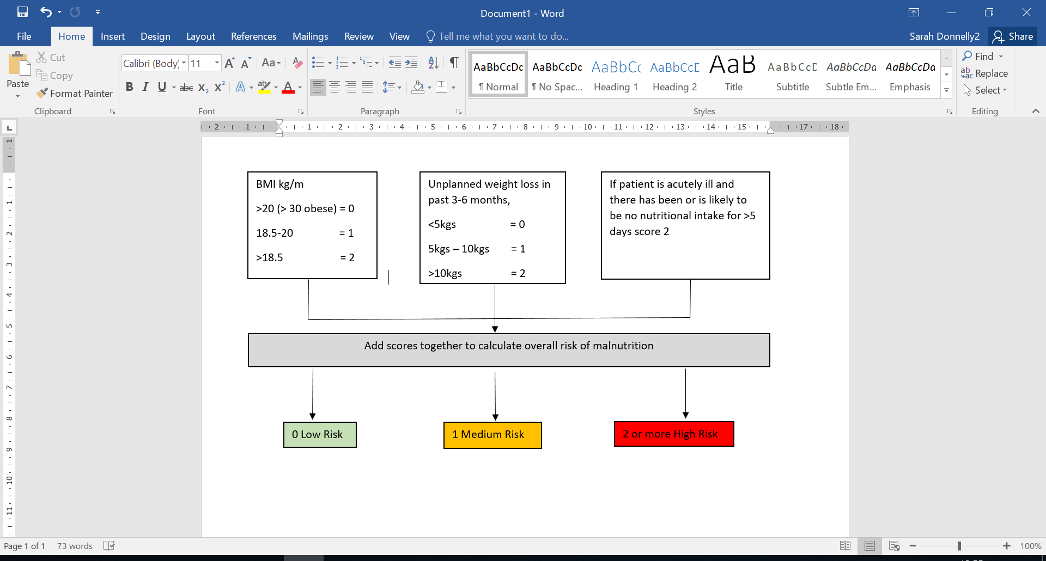
Score | Interventions | Tick
0 Low Risk | - Monthly weight check and re asses.
1 Medium Risk | - Document dietary intake for 3 days review with MDT.  - Document in ICP, review at MDT.  - Repeat screening weekly or as per ICP.
2 or More High Risk | - Document dietary intake on daily basis,  - Document in careplan and review with MDT,  - Carry out Waterlow assessment scale,  - Repeat screening weekly
Covid Vaccination Status

Has patient received Covid19 Vaccination: YES □ NO □ Not Known □
If Yes please give detail (i.e. quantity, date of last vaccination)________________________________
Falls Risk Assessment
Question | If Answer Yes please tick
Is patient aged 65years of age or older ?
Has the patient history of falls (1 or more in last year) ?
History of unexplained falls ?
Has a problem with gait and balance ?
Has a problem with gait and balance ?
Has a fear of falling ?
* Please complete Falls Risk Assessment (FRAT) if any above are ticked or your professional Judgement indicates it*
FRAT assessment indicates Medium or High risk of falls refer to Physiotherapist email: Shabu.paul@hse.ie

Completed by: ___________________________ Date: ________________________

